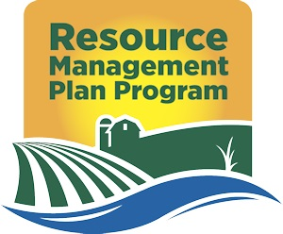

Virginia Agricultural Resource Management Plan (RMP)
Developer Certification Statement
RMP – 00-00-0000

Prepared for:
Prepared by:
RMP Certification #:
NMP Certificiation #:
NMP Certificate Expiration Date:

I certify that the following information has been prepared by me or under my direction and meets the requirements of the Virginia Resource Management Plan Regulations. I have reviewed all plan(s) included that were prepared by others and also certify those plan(s) were prepared by qualified individuals and meet the requirements of the Virginia Resource Management Plan Regulations.

I understand that I am accessing the module for this Resource Management Plan (RMP) on behalf of the owner or operator of the management unit and that in the event such owner or operator elects to select a different certified RMP developer, DCR may, in accordance with the written request of the owner or operation and regardless of any contractual obligations between me and such owner or operator or any claims that such may arise between the same, assign my access authority to this specific Resource Management Plan to such certified RMP developer and revoke my access to this RMP. I herby consent to DCR’s reassignment of access in such circumstance and waive any and all claims against DCR that may arise in connection with handling of the RMP module access as described above.

RMP Planner Signature:__________________ Date:__________________

